ministry of agriculture, fisheries and food CSG 15

Research and Development

Final Project Report
(Not to be used for LINK projects)
Two hard copies of this form should be returned to:
Research Policy and International Division, Final Reports Unit
MAFF, Area 6/01
1A Page Street, London SW1P 4PQ
An electronic version should be e-mailed to c.csgfinrep@csg.maff.gsi.gov.uk

Project title | Reduction of cetacean bycatch in pelagic trawls

MAFF project code | MF0733

Contractor organisation and location | Sea Mammal Research Unit  Gatty Marine Laboratory  BackgroundUniversity of St Andrews, St Andrews, FIFE KY9 1JB

Total MAFF project costs | £ 40304

Project start date | 31/01/02 |  | Project end date | 31/05/02

Executive summary (maximum 2 sides A4)

Observations in the bass pair trawl fishery in the Channel during January February and March of 2001 indicated that this fishery has a relatively high, though also unevenly distributed, bycatch of common dolphins. A total of 53 common dolphins were observed caught in 12 of the 116 tows observed, covering 71 days at sea. Initial attempts to minimise bycatch through the use of pingers during the 2001 season were unsuccessful. The present project aimed to test the applicability of an exclusion grid in this fishery as a potential means of minimising dolphin bycatch. Exclusion grids have been deployed successfully to eject other marine mammals (sea lions and furs seals) from the aft sections of trawls in Australia and New Zealand.

Observations during the 2001 season suggested that most if not all dolphins were found at the extreme end of the trawl sleeve, in front of the cod end and the ‘flappers’ (the net curtain that discourages fish from swimming out of the cod end) oriented towards the cod end. Many had their beaks poked through the 4.5 cm meshes of the sleeve. This suggests that the animals were able to swim actively to this point of the net and were alive when they reached the rear part of the sleeve. The net used is approximately 200m from the wings to the start of the final section or sleeve, and about 150m from the trailing edge of the headline to the start of the sleeve. The sleeve itself is a 25m long tube about 1.5m in diameter. An actively swimming common dolphin should be able to reach the codend from the wings in less than a minute while swimming at typical speeds (3 m/s). Even a stationary animal would pass from one end of the net to the other in under 2 minutes at normal towing speeds. Surfacing intervals of 1 to 4 minutes are recorded for common dolphins, and it seems likely that maximum dive durations under duress should exceed this. It seems very likely therefore that an exclusion grid placed at the entrance to the sleeve should be able to intercept animals swimming towards the rear of the net well before they would likely become hypoxic.

The project was initiated with a workshop in January 2002 to discuss design features of the proposed grid. Both skippers and gear technologists were present. We considered grid angle, bar spacing, construction material, escape hole placement and size and the cover net. We contracted Bjornar Isaksen of the Institute of Marine Research to design a grid suitable for use in the bass pair trawls based on the conclusions reached at the workshop. He used a stainless steel rigid grid design with four internal bars set at 22cm apart. The spacing was decided based on anatomical measurements of 241 common dolphins made by the Institute of Zoology under another DEFRA contract. Stainless steel was chosen as a simple initial choice of material, being least likely to break or distort, though it was recognised that if the design should prove successful, other less heavy materials might be tested.

We decided to monitor the grid during deployment using a camera with a cable to the wheelhouse. This would enable us to see how dolphins might behave in the confines of the trawl sleeve when confronted with a grid, and also see how bass behave under the same circumstances.

Sea trials were planned for two 4-day trips in March, during which we anticipated observing 16-20 tows. Data from 2001 suggested that this should provide us with a high probability of observing at least two tows with dolphins.

The initial trip starting on March 18th was unable to proceed as planned because the camera cable parted in a heavy swell before monitoring had begun. The grid was then removed from the net, because the skippers were concerned about loss of fish in an unmonitored net. The second trip was delayed until a new cable could be manufactured and supplied. This trip started on April 8th and ran for 4 days. We made video recording for over 45 hours covering 7 tows with the grid in place and 2 tows without the grid. No dolphins were observed in these tows. Video recording demonstrated that bass are very powerful swimmers and are easily able to outpace the trawl. Most bass enter the sleeve actively swimming towards the cod end, while a significant number were also observed to swim in the opposite direction, past the camera and towards the trawl mouth. Very few however reacted to the grid by changing their swimming direction in this way. The video recording suggested that behaviourally bass would be unlikely to be affected by the presence of the grid. A few fish found their way out of the escape hole by pushing through the escape net. A slightly heavier leadline holding the escape cover shut initially helped to reduce the number of such escapes. After the first few tows however, the grid appears to have altered orientation slightly, possibly due to changes in the buoyancy, and there were further incidents of bass escaping. Consequently for the last two tows of the trip, the grid was removed again to prevent loss of fish.

Skippers were enthusiastic about the grid’s performance, though recognising that there were some construction details that would require attention to ensure that bass loss could be minimised. Reviewing the video tapes with the skippers and with Bjornar Isaksen, three aspects of design were highlighted for improvement. These were: 1) grid angle – the grid angle appeared to be shallower than intended, which might explain some of the observed fish loss. 2) Floatation – floats were too widely dispersed and should have been fixed closer to the top of the grid. 3) Escape cover – a smaller escape cover net either fitted with a hydrofoil depressor or rigged with more slack might also have minimised fish escapes. These design improvements should be tested to ensure that bass escapes can be minimised before the grid is deployed again in the commercial fishery.

Our conclusion with respect to the camera work is that future projects should concentrate on ensuring a viable video monitoring system, preferably with more than one camera, and using a suitably robust cable. One issue of concern is that any dolphins that negotiate the escape outlet should be unharmed and able to swim away. Clearly an additional externally mounted camera on the net would make this much easier, and would also make it easier to determine the extent of any fish loss.

We suggest that this preliminary trial demonstrates that the grid can be made to work in the bass fishery from a gear handling and a fish catch perspective. Whether or not dolphins will allow themselves to be ejected through the escape outlet remains to be seen, but the limited room for manoeuvre in the sleeve suggests that they would have few alternatives. Having demonstrated the potential of the system, we propose that development should be continued with a chartered cruise to ensure that the system can now be made to work to the skippers’ expectations.

Scientific report (maximum 20 sides A4)

Background

Annual strandings of common dolphins (Delphinus delphis) along the south coast of England, and in France, during the first three months of the year have been associated with bycatches in fisheries, including pelagic trawl fisheries operating in and around that region (Kuiken et al. 1994). Previous on-board observer programmes have suggested annual takes of around 200 dolphins per year in the hake gill net fishery (Tregenza and Collet 1998), and dolphin bycatches have also been observed in horse-mackerel fisheries operating in the Celtic Sea and Channel, in tuna pair trawls and driftnets operating in the Biscay region (though in the summer only), in French hake pair trawls and in French bass pair trawls (Morizur et al. 1996).

The origin of the animals that strand along the French and English coasts during the first three months of the year is still not clear, though recent observations in the UK bass pair trawl fishery suggest that a proportion of the stranded animals may come from that fishery, at least during the month of March. Other fisheries that operate in the region during the late winter include a wide range of gillnet fisheries, a variety of demersal trawl fisheries and pelagic trawl fisheries for horse mackerel, mackerel, sardines, anchovies, herring and black sea bream. Nations involved include France, Ireland, Spain, Netherlands and Denmark as well as the UK. Even within a fishery category of a single target species and nation, different gear types may be used, so that it is extremely difficult to characterize fishing métiers in a manner that might usefully reflect their potential threat to cetaceans.

Clearly, however, there is a need to develop means of minimising such dolphin bycatches. Not only does the scale of the bycatch warrant such actions, but also, the lack of any known mitigation measure is a serious impediment even to determining which métiers are involved. The lack of international progress in tackling this problem is in part due to fears of pre-emptive fishery closures. The development of a viable mitigation method or methods is therefore an important pre-requisite if the collaboration of the various sectors involved is to be achieved, and if the issue is to be addressed equitably.

Preliminary observations & trials in the pair trawl bass fishery.

The Sea Mammal Research Unit has been working in collaboration with the Scottish Pelagic Fishermen’s Association to address this matter since 2000. At a meeting with skippers in Fraserburgh in December 2000 it was agreed that on-board observations of the two Scottish bass pairs involved in the UK bass trawl fishery would begin in January 2001, and that attempts to minimize or eliminate any dolphin bycatch would also be initiated as soon as possible. Skippers reported that the main bass season began in March, and that bycatches of cetaceans would be expected only after the beginning of March. The UK bass trawl fishery employs trawl nets towed near the surface by a pair of relatively small trawlers (30-40m range; see also Figures 1 & 2).

Figure 1: General configuration of a pelagic pair trawling operation
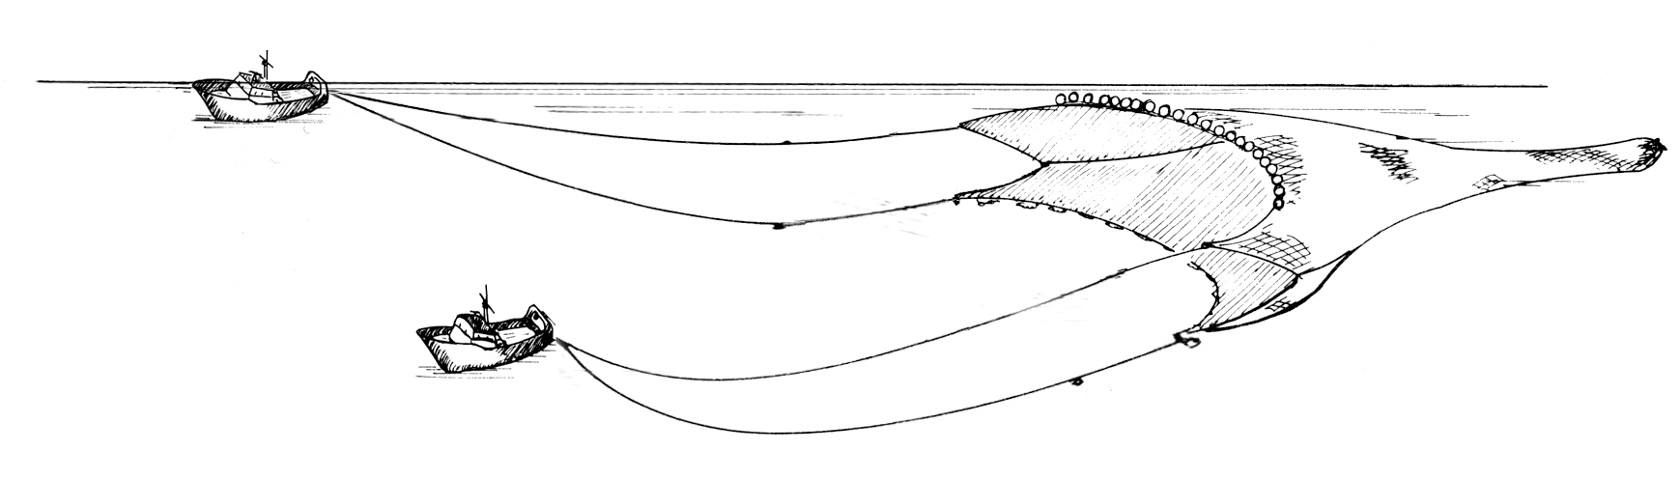

Figure 2: Catch being taken on board a bass trawler in the Channel

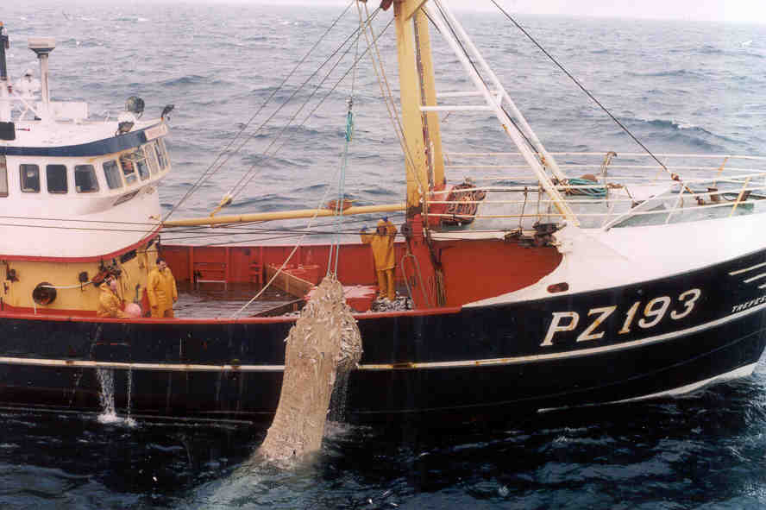

At the Fraserburgh meeting three methods of mitigation were discussed:
- 1) Pingers. Acoustic deterrent devices (pingers) have been shown to be effective in keeping common dolphins and some other species of small cetaceans away from static gear. Bycatches of common dolphins in the California shark driftnet fishery had been substantially reduced through the use of pingers ((Barlow and Cameron 1999)). It was postulated that the same devices might work in a pelagic trawl, even though the mode of capture and mode of fishing were very different from those tested previously.
- 2) Loud acoustic warning devices. A second acoustic method was also discussed, where it was suggested that a much louder warning noise than that of a pinger, and similar to the seal scaring devices used by salmon farmers, might be emitted from a source situated towards the rear of the net prior to hauling, in order to scare animals out of the net.
- 3) Selection grids. The use of an exclusion or selection grid was also discussed. Such devices are widely used in other fisheries. By placing a widely spaced metal grid (through which fish could pass but larger animals such as dolphins would be unable to pass) in the extension piece of the trawl, dolphins and other large animals would be guided out through an escape hatch or outlet built into the trawl netting while fish would continue through the grid and into the cod-end.

These three options were discussed and it was agreed that given the shortage of time before the 2001 season began, it would not be possible to plan for the implementation of either the second or third options. It was also recognized that the second option (loud acoustic warning device) would rely on such a warning device scaring animals out of a net rather than into it, and also assumed that capture normally occurs at the end of a tow. There was no evidence to substantiate this assumption. The third option (selection grid) assumed that dolphins are caught and drowned towards the back end of the trawl rather than in the belly or wings, and again there was at the time no evidence to substantiate this assumption. The first option (use of pingers) was accepted in the first instance because pingers were readily available and because it would be the least intrusive to fishing operations. It was recognized, however, that the very different circumstances in which these devices would be tested in a trawl fishery might not be comparable to those found in gillnet fisheries.

At sea observations during 2001 resulted in observations of 116 tows during 71 days at sea. Dolphin bycatches were observed in 12 of these operations, with a total of 53 common dolphins reported caught. All but one of these animals was reported caught during the month of March, as predicted by the skippers involved. March is also the month of most activity in this fishery, though limited fishing also occurs in other months from November to April. Skippers remarked that the numbers of animals taken was higher than would usually be expected.

Pingers were deployed in 15 of 52 tows observed during March 2001. Up to 12 pingers were attached around the entire mouth of the trawl, with the intention of deterring animals from entering. Several pingers were lost during fishing, but were replaced whenever possible. Dolphin bycatches were not reduced in the 15 tows with pingers, as shown in Table 1.

Table 1: Results of Pinger Trial

Pingers: | No of tows | No of dolphins bycaught
Deployed | 15 | 19
Not Deployed | 37 | 33

While we do not therefore conclude that pingers can never be made to work, we did conclude that the use of pingers was not a promising avenue for research, given the urgency of finding a workable mitigation measure.

Observations during the 2001 season also revealed that bycaught dolphins are generally observed far back in the extension piece of the trawl, usually near the flappers in front of the cod end, and often with their beaks protruding through the netting. These observations led us to speculate that in becoming caught in trawls, dolphins swim the length of the trawl net, and are alive when they reach the distal end of the extension piece. We did not observe animals caught in other parts of the trawl, and the fact that most if not all animals were orientated with their heads towards the cod end, and many with their beaks protruding, suggests that in this fishery and with this species (common dolphins), the animals actively swim as far as the cod end before drowning. Necropsy results of stranded animals show that a proportion have beaks with post-mortem breaks consistent with our observations, and that such animals have drowned, and often display muscle and ligament tears consistent with a violent struggle to escape.

After the 2001 fishing season we therefore began to investigate the possibility of employing an exclusion grid during the 2002 season on the assumption that such a device, if deployed near the front end of the extension piece would enable dolphins to escape before they had traveled much further towards the cod end, in the expectation that they would be alive at this point. An examination of the trawl net plans suggested that such a point is roughly 100-150 meters from the mouth of the trawl. At the mouth of the trawl the mesh size of the net is 9m, with gradually decreasing mesh sizes to around 6 cm at the beginning of the extension piece. The nearest meshes that an animal of this size might reasonably still be expected to escape from, i.e. about 80cm. Are just 50m from the entrance of to the extension piece.

Common dolphins have been observed to dive to depths of 200m, a round trip of at least 400m from the surface assuming a vertical dive and ascent, while dives of up to 4 minutes have also been recorded (Evans 1994). These figures are unlikely to represent maxima. At typical bass-trawling speeds of 100m per minute (3.5 knots), even a stationary animal in the path of the trawl would pass from the headline through the trawl as far as the grid location within 2 minutes. At typical swimming speeds of 2-4m/sec (Williams 2002) a dolphin swimming directly into the net would pass from the headline to the grid in 22-47seconds.

The observed frequency of captures of dolphins in the 2001 UK bass pair trawl fishery suggested that the success of otherwise of any mitigation device could be tested relatively quickly.

We therefore began to develop the idea of using a selection grid, and the present project was intended to test the feasibility of such a system. To this end we enlisted the support of the Sea Fish Industry Authority for assistance with gear construction and the Institute of Marine Research in Bergen for their expertise in selection grid design and deployment.

The objectives of the present problem were as follows:
- 1) Design a suitable exclusion grid system
- 2) Construct a scale model to test hydro-dynamic performance in a flume tank
- 3) Construct a full scale prototype
- 4) Test the prototype in the fishery to determine
  - a. Ease of handling
  - b. Fish capture / loss
  - c. Dolphin escape potential.

Preliminary workshop

A workshop was held in Aberdeen [1]on January 3rd 2002 in order to begin the specifications for an exclusion device. In attendance were Simon Northridge (SMRU), Phil MacMullen (SFIA), Bjoernar Isaksen (IMR, Norway), Derek Duthie, Steven West and John Buchan (SPFA).

The workshop began with a brief summary of existing grid technology from Bjoernar Isaksen. He explained that exclusion grids or selection grids have been used for several decades around the world to improve fish selectivity in many different kinds of fisheries. He also explained that he had designed a sea lion exclusion device whilst working in New Zealand in 1995 (Gibson and Isaksen 1998). The basic principle is shown in Figure 3. Although the squid trawls used in New Zealand are somewhat different from the bass trawls used in the UK, the principle is the same, and the fact that New Zealand (Hooker’s) sealions (Phocarctos hookeri) are very similar in size to (females to 2m) or larger than (males to 3.5m –(Walker and Ling 1981)) common dolphins (to 2.6m – (Evans 1994)) suggests that the animals’ size need not be a problem.

Several key aspects of design were discussed, including rake angle of the grid, grid spacing, construction material, escape outlet size and placement, the use of guiding nets or flappers, and the details of the outlet cover.

Rake angle
The angle at which the grid is set into the net with respect to the vertical plane is a compromise between that which is best to ensure the smooth passage of the fish (vertical) with that which is better to guide larger animals out (a very sloped grid with respect to water flow would be best); as a compromise, a rake angle of 40º to the vertical was suggested. This could be experimented upon if necessary.

Figure 3: Basic principle of the seal exclusion device
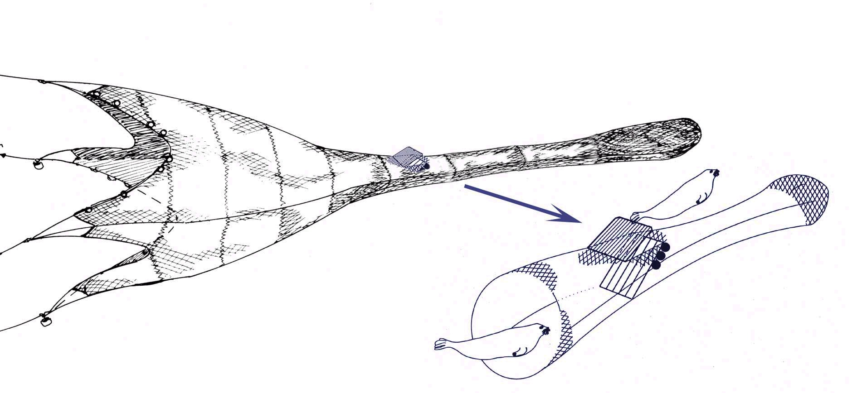

Grid spacing
Grid spacing again is a compromise between that which is large enough to ensure smooth passage of the fish, with that which is small enough to ensure the bycatch species is ejected rather than passing through the grid, or worse, becoming wedged in it. To address this we examined post-cranial /thoracic girth or circumference measurements of 241 common dolphins in relation to total length. We further made the conservative assumption that the cross-sectional area of this region is circular, and calculated the diameter accordingly (Figure 4). A grid spacing of 22 cm was agreed. It was noted that (a) the post-cranial diameter is not necessarily the widest part of the animal, (b) that pectoral fins extend beyond the flanks of the animals, and that (c) most bycaught animals are in the 2m+ size category, so that this spacing is probably conservative, and will guard against animals becoming wedged in the grid.

Construction material.
Grids have been constructed of various materials, including plastics to enable them to be wound onto a net drum. It was agreed that initially stainless steel would be the best material to use because of its strength, in view of uncertainties over just what kinds of forces it might be exposed to. To counteract the weight of the device, buoyancy aids would be required along the sides of the device to make it almost neutrally buoyant. The possibility of using a hinged grid, to assist storage on a net drum, as is done in New Zealand was also discussed, but it was concluded that this would be unnecessary at this stage, as the device could be handled and stowed on deck without needing to wind it on to a net drum.

Figure 4 Thoracic diameter of 241 common dolphins by body length[2]
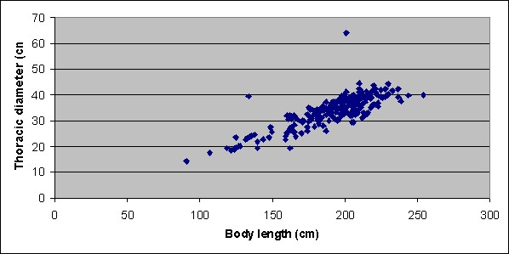

Outlet size and placement.
The outlet size needs to be sufficient to enable a 2.5m animal with a maximum body diameter of perhaps 70cm. The outlet needs to be immediately in front of the grid as an animal approaches it.

Guide nets
In some fisheries it has proven useful to use a guide net in front of the selection grid to force the target species of fish down towards the base of the grid, thereby minimising the number that try to escape through a top-mounted escape outlet. Larger non-target fish in such fisheries are also deflected downwards, but being unable to pass through the grid are forced to swim back upwards again after passing the guide net and so out of the escape outlet. It was reckoned that such a net might well impede the passage of dolphins down the extension piece and present a threat of entanglement, so it was agreed to proceed initially with no such guide nets.

Outlet cover.
The escape outlet cover is critical in limiting fish loss and there are numerous ways in which this can be designed. After some discussion it was agreed that as a first step, a simple netting cover, using a very small mesh nylon net in which a dolphin would be unable to catch its beak, would be the best option. This would be weighted down around the edges with light-weight leadline to ensure that the net does not rise up during towing, while the cover net itself should be large enough to extend well beyond the edges of the escape outlet to minimize the chances of fish escaping.

Through all of these discussions it was recognized that there are many alternative options that might be taken during the design of a selection grid, and that only experience would determine which were the best such options. One of the key factors in the success or otherwise of the device would be the behaviour of the target species of fish. It was unknown how bass might behave in such a situation, a grid never having been tried in a bass fishery before. Clearly one of the two main objectives of the grid should be to minimize target fish escape.

Monitoring Fish Escape
In order to address this, two options were discussed. One involved using an extra cover net or bag over the escape outlet in order to collect escaping fish, and thereby quantify the fish loss. The problem with this method, which is used in New Zealand with the experimental sea lion escape devices, is that the target of the grid (i.e. the sea lions or the dolphins) also drown in the cover net. It was suggested that such a bag might be used in just one or two tows to address fish loss rates.

A second option was to monitor the outlet by video camera. The possibility of using a self-contained video recorder (camcorder) was discussed, but this was ruled out for two reasons. Firstly, it does not on its own enable wheelhouse monitoring of what is going on in the extension piece, and secondly, we could not find a commercially available camcorder capable of capturing a typical 7-hour tow. We therefore agreed to try to establish a cabled link between a high definition underwater camera and a monitor and recorder in the wheelhouse, a distance of some 500m.

Scale model trials

Isaksen provided detailed specifications to the Sea Fish Industry Authority, based on the above discussions, and a one-fifth scale model was constructed in stainless steel and tested in the flume tank in February 2002.

The device was found to perform well, maintaining correct orientation in the water, and without hindering the simulated towing of the net. A water-filled balloon was used to simulate the passage of a large animal, such as a dolphin, and this exited the escape outlet and the covering net as planned.

Sea Trials - Narrative

We had agreed with the skippers involved that we would test the grid on just two trips. The risk of the device not working and causing fish loss was considered too great to take on more of a risk than this. It should be stressed that we were not chartering the vessels, and that much of the risk of the devices not working was borne by the fishermen themselves. We also agreed that they could terminate the trial if the grid appeared to be resulting in the loss of too many fish. All trips by the two pairs of Scottish bass trawlers were monitored by SMRU observers during March and April, while additional staff from IMR and SFIA were also present during the two grid trips.

Each trip lasts four days, and usually consists of around 8-10 hauls. We therefore hoped to observe around 16-20 hauls with a high probability of observing dolphins in the extension piece during one or more of those hauls, based on our observations in 2001.

A full-scale prototype grid was constructed in Hull in the first week of March, and was fitted to a short extension piece to be inserted into the trawl at the back of the tapered section, and at the front of the existing extension piece. A suitable camera and recorder were obtained, and an appropriate cable was also acquired. These were tested to ensure that a sufficient signal could be received through a 500m length of cable.

The camera cable turned out to be a critical matter. The cable options had included a simple mini-tv cable, a kevlar re-inforced mini-tv cable, or a steel re-inforced video cable. The latter such cable is the most expensive, and had the disadvantages of needing a large winch, and of being extremely heavy and therefore more difficult to handle onto and off the boat. Kevlar re-inforced cable is used to tow remote underwater vehicles and has been successfully used with cameras on sleds to examine sandeel distribution on the seabed. Mini-tv cable is robust, and is the cheapest option, but is not intended for towing cameras. We opted for the mini-tv cable because we were not intending to tow the camera, but rather to allow the cable to fly freely to the camera, the camera being attached to and towed by the trawl.

Although one of the two Scottish pair trawlers had been fishing for bass sporadically from January to March, the second pair, with whom we were working, were not scheduled to begin fishing until the start of March. A successful mackerel season, however, meant that the start of the bass fishery was delayed until March 15th for this pair, and we did not begin sea trials until March 18th.

The first trip was accompanied by Norman Graham from IMR, who successfully installed the camera equipment onto the trawl. The camera cable was wound onto the ships
Netsonde cable drum and the camera was deployed inside the extension piece about 3 meters in front of the grid. The week of the 18th March followed some extreme bad weather in the Channel, resulting in a heavy swell. On the first tow of the equipment the camera cable snapped almost immediately, because of the heavy seas, even though it was not actually towing anything. It seems likely that the sheer weight of water was enough to break the 500 m length of cable.

A cover net bag was not installed because of the unforeseen proximity of the extension piece to the water’s surface, which it was felt might cause the cover net to drag the net with possibly disastrous consequences. We were therefore unable to address fish loss with this method.

During the first tow, however, the cover net itself, which covers the escape outlet, was stitched closed over the escape outlet. This was a precaution prior to ensuring visually with the camera that the system would behave as planned. The intention was to observe the behaviour of the bass for one tow before opening up the escape outlet. Without a camera this proved impossible, but after the first tow there were no fish caught up between the cover net and the outside of the extension piece, suggesting a low rate of escape through the escape outlet.

With no means of determining fish loss the grid was removed from the trawl for the rest of this first trip, and meanwhile a new and stronger cable was sourced from suppliers in Aberdeen. A steel re-inforced cable could not be obtained within a short space of time, and we therefore had to order a kevlar re-inforced cable with a breaking strain of 1.5 tonnes. This is equivalent to the breaking strain of the existing netsonde sonar cable used by the same pair in other fisheries. The new cable had to be manufactured specially and was not ready for delivery until April 6th.

A second grid trip took place between April 8th and April 11th, accompanied by Roger Horton from SFIA who was responsible for setting up and running the camera and video equipment. On the first haul the jubilee clips holding the camera in position inside the net snagged the meshes preventing the trawl from opening, but this was rectified by taping down the clips. On the second haul the camera cable became entangled in the headline floats and the net had to be hauled and re-shot. The following 7 hauls were made with the camera and grid in place. On the 10th haul the grid was removed again, as it appeared that changes in the cover net orientation were allowing fish to escape, but the camera was left in place to monitor fish and any dolphin presence. On the 12th and final haul, the trawl headline parted, breaking the camera cable at that point.

Results

Video footage of the initial hauls shows bass and other fish (garfish, scad) swimming through the grid with little or no evidence of fish escaping through the escape outlet. Subsequently the gear orientation may have shifted slightly and some minor fish escapes were observed, so the cover net was weighted down slightly more with additional light-weight leadline. This seemed to work for another few hauls, but on the 9th haul, further fish escapes occurred, prompting the skipper to remove the grid. At this point the video footage suggests that the grid may have shifted in orientation slightly, lying flatter or at a shallower angle than in the initial tows. This may have affected the orientation of the escape outlet and the cover net, allowing a window to open up for fish to escape through.

The first six hauls resulted in very few fish being caught, but the video tapes show few fish swimming in the extension piece either. Over the last six hauls fish catches were almost identical for the three hauls when the grid was present (mean = 11.3 boxes) to the three hauls when the grid had been removed (mean = 10.6 boxes). Nevertheless this is not a good way to measure the effectiveness of the grid, as bass catches are notoriously variable.

The skippers reported that the grid did not present problems in handling, once the initial problems with the jubilee clips and cabling had been sorted out.

No dolphins were seen while the grid was deployed. Indeed, among 37 tows observed during March 2002, only 2 tows (5%) had any dolphin bycatch (8 animals in total), and these were the only two bycatch tows observed throughout the year from January to April 2002 (66 tows were observed in all). This compared with dolphin bycatches in 11 out of 52 (21%) tows in March 2001. These very much lower bycatch rates mean that we were unable to observe any dolphins in the nets as we had expected to, and therefore have no direct evidence of how dolphins will behave in relation to the grid.

We did however observe and record a shark, probably about 1.5m in length, which encountered the grid and appeared to escape up through the escape outlet with little problem, proving the concept of the exclusion grid in this fishery if not in the anticipated manner.

A video presentation of the trial has also been prepared (Escaping the Net © University of St Andrews) and has been submitted with this report. Video frames and results will also be published via the SMRU website shortly.

Discussion

We believe that these preliminary trials demonstrate the feasibility of an exclusion grid for use in this fishery to reduce or eliminate cetacean bycatch. Most of our objectives for this project have been met, though clearly the absence of observations of any dolphins negotiating the escape outlet is one objective that we did not attain. On the positive side this is mainly due to the fact that very many fewer animals were caught in 2002 in this fishery overall as compared with 2001.

The design and testing of the device were achieved as planned, and the field trials, though not without incident, were also successful in demonstrating that an exclusion grid system can be put in place in this fishery without causing undue handling or fishing problems. Fish loss could not be quantified exactly, because we were in the end unable to apply a collecting bag. The video footage does provide a means of estimating fish loss though this would be extremely time consuming with over 40 hours of video to examine, much of it necessarily in slow motion, and we have not done this. It is clear that for most of the time fish loss was minimal, but that on some occasions fish were escaping, probably due to changes in the orientation of the cover net. This needs to be examined further. Further work will therefore be required to refine the design of the system to ensure that the observed increase in fish loss at the end of the trial can be eliminated.

During review of the video tapes with Bjornar Isaksen and Martin Cawthorn, three aspects of design were highlighted for improvement. These were firstly the grid angle, which appeared to be shallower than intended, and which might have explained some of the observed fish loss. Secondly the floats attached to the grid were too widely dispersed and should have been fixed closer to the top of the grid. Thirdly, the escape cover could also have been improved either by fitting it with a hydrofoil depressor or by rigging it with more slack, both approaches might have minimised fish escapes. These design improvements should be tested to ensure that bass escapes can be minimised before the grid is deployed again in the commercial fishery.

Under ideal conditions one should be able to monitor the performance of the grid and make fine scale adjustments to it, and to the escape outlet and other parts of the gear on a tow-by-tow basis. This however is not practical in a commercial fishery, where minor differences in catch rates can lead to enormous financial losses. Further trials would therefore best be done with a chartered vessel.

During the project it became clear quite how critical the use of real-time video monitoring is for this type of work. Indeed, our conclusion with respect to the camera work is that future projects should concentrate on ensuring a viable video monitoring system, preferably with more than one camera, and using a suitably robust (steel) cable. One issue of concern is that any dolphins that negotiate the escape outlet should be unharmed and able to swim away. Clearly an additional externally mounted camera on the net would make this much easier, and would also make it easier to determine the extent of any fish loss.

Given the international nature of the bass fishery in the Channel and Biscay region, it is hoped that future exclusion grid development work can be conducted in collaboration with French partners. For this reason a preliminary presentation of this work was made to representatives of the French industry and French fisheries scientists on April 28th 2002, and we are hopeful that a collaborative project can be established. It may be that other trawl fisheries with a similar bycatch issues to address may also find this approach useful.

Acknowledgements

Numerous individuals were critical to the success of this project. Chief among these are the skippers, Steven West and John Buchan, and the crews of the two fishing vessels involved in the trials. Dave Sanderson and Rob Forster of the SMRU have provided the detailed observations over many fishing trips that have made this work possible. Derek Duthie at SPFA has been instrumental in getting the whole project going in the first place. Keith Moir at MacCartneys in Aberdeen dealt with all of our cabling problems, without losing his cool once, while Charlie Shand at the FRS Aberdeen provided helpful advice on video and cabling matters. Ken Arkley, Phil MacMullen and Roger Horton at SeaFish provided admirable technical expertise in constructing and testing the grid, and in handling the problems that we encountered with the video monitoring system. Norman Graham of IMR provided valuable assistance and observations during the first at-sea trial, while Bjørnar Isaksen provided his skill and vast experience in designing the system in the first place. Martin Cawthorn also provided helpful insights after the trial based on his experience woring with similar systems in New Zealand.

References:

Barlow, J., and G. A. Cameron. 1999. Field Experiments Show that Acoustic Pingers Reduce Marine Mammal Bycatch in the California Drift Gillnet Fishery. Presented to the Scientific Committee of the International Whaling Commission, Grenada, 1999.
Evans, W. E. 1994. Common dolphin, White-bellied porpoise Delphinus delphis Linnaeus, 1758. in S. H. Ridgway and R. Harrison, editors. Handbook of Marine Mammals vol 5. Academic Press, London.
Gibson, D., and B. Isaksen. 1998. Functionality of a full-sized marine mammal exclusion device. Science for Conservation 81:19.
Kuiken, T., V. R. Simpson, C. R. Allchin, P. M. Bennett, G. A. Codd, E. A. Harris, G. J. Howes, S. Kennedy, J. K. Kirkwood, R. J. Law, N. R. Merrett, and S. Phillips. 1994. Mass Mortality of Common Dolphins (Delphinus-delphis) in South- West England Due to Incidental Capture in Fishing Gear. Veterinary Record 134:81-89.
Morizur, Y., N. Tregenza, H. J. L. Heessen, S. D. Berrow, and S. Pouvreau. 1996. By-catch and discarding in pelagic trawl fisheries. Contract Report Contract EC DG XIV-C-1, IFREMER, Brest.
Tregenza, N., and A. Collet. 1998. Common dolphin Delphinus delphis Bycatch in Pelagic Trawl and other Fisheries in the Northeast Atlantic. Rep. Int. Whal. Commn. 48:453-459.
Walker, G. E., and J. K. Ling. 1981. New Zealand Sea Lion - Phocarctos hookeri. Pages 25-38 in S. H. Ridgway and R. J. Harrison, editors. Handbook of Marine Mammals Vol 1. Academic Press, London.
Williams, T. M. 2002. Swimming. Pages 1213-1222 in W. F. Perrin, B. Wursig, and J. G. M. Thewissen, editors. Encyclopedia of Marine Mammals. Academic Press, London.

[1] Thanks to Mike Breen at FRS for organising space for this meeting

[2] Thanks to Paul Jepson at the Institute of Zoology for use of these data

[1] Thanks to Mike Breen at FRS for organizing space for this meeting
[2] Thanks to Paul Jepson at the Institute of Zoology for use of these data

